Trial Host: Rancho Mondo NW K9 Center

Novice/Intermediate Level/Variable Trial February 17, 18, 2017
Location: Rancho Mondo NW K9 Center
16218 Round Mountain Rd
Leander, Texas 78641
Chief Search Designer:
TBD
Judge(s):
Hank Amen
Esther Bell

Entry Cost:
$20 per class or game before deadline
$25 per class or game at day of trial

Number of Entries:
35 entries per day
Multiple dogs allowed
Titling dog must run first
For exhibition only entries taken
Day of show entries allowed if there is room

Registration Entry and Closing:
Entries will be awarded by first come first serve of all entries received between December 15, 2018 to February 10, 2018

Steps for Joining USCSS™, Registering Dog and Entering this Trial:

- All competitors must become a member of USCSS™, which is free. Competitors may join here: http://members.uscaninescentsports.com/signup.
- Competitors must then register their dog(s) through the USCSS™ website. Each registration includes a one-time $25.00 fee. Competitors may register their dogs here: http://members.uscaninescentsports.com/login?redirectTo=http://members.uscaninescentsports.com/dog/register
- When logged into their account on the USCSS™ website, competitors may then scroll down to the “LOCAL EVENTS” section, find the trial they are interested in entering and click on the ENTER button.
- Competitors may then select which dog they are entering and select which Classes and/or Games they are entering.
- Competitors will then receive a confirmation email with details regarding their entry and instructions on how to submit payment for their entry. All payments will be sent directly to the trial host, not USCSS™. The confirmation email will specify how payment will be made (e.g. via PayPal, mailed check, etc.). Competitors should note that their spot in the trial will only be held once payment is made.

Classes offered on February 17
- (1) Container
- (1) Vehicle
- (1) Interior
- (1) Exterior

Classes offered on February 18
- (2) Vehicles
- (2) Exterior
- (1) Team Spirit

Check-in time is 8:15 February 17 and February 18 for all classes. Briefing time is 9:00 | First dog on the line at 9:30 Check in time for the game is 12:30p.m. Game starts 1:00p.m.
Dogs must have valid USCSS™ registration numbers to compete in this trial. Handler may run multiple dogs, but titling dog must be run first.

AWARDS
- High in Trial rosette and USCSS™
- High Rescue in Trial rosette
- High Champion of record rosette
- Dogs must be entered in a minimum of 4 classes at each trial to be eligible for any HIT awards
- 1st - 4th place overall
- 1st - 4th place per class
- High in Trial wins a complimentary portrait session on the Red Couch with a photographers’ choice 11x14 print mailed to you. A gift certificate will be issued at the trial and an appointment is necessary to finalize the portrait session.
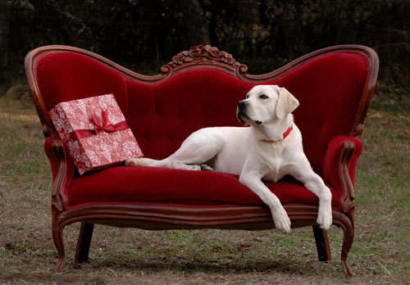

LUNCH
We will have lunch at approximately noon and will take breaks at the Judge’s discretion.
There will be a potluck where everyone can contribute so all can enjoy. You are welcome to visit and share recipes around the potluck table that will be under the canopy of oak trees.

VOLUNTEERS
Every trial needs volunteers. Volunteers may run their dogs first and then volunteer so you and you dog can still enter the trial. Please let us know if you would like to volunteer. Please contact Julie Kay Locke at julie@ranchomondok9.com or 512 940-7574.
*

LODGING
Motel 6 - Cedar Park, TX. 800 Arrow Point Dr. (no pet fee) 512 260 3233
La Quinta - Cedar Park TX 1010 E. Whitestone Blvd. (no pet fee) 512 528 9300

VETERINARIAN
- Leander Vet Clinic
11699 Old 2243 West Suite 110
Leander, TX. 78641 512 260-0400

Photographer: TBD

Videographer: TBD

THIS IS A SELF CLEANING SHOW. PLEASE CLEAN UP AFTER YOUR DOG!

Trial Chairperson
Julie Kay Locke
julie@ranchomondok9.com

United States Canine Scent Sports
info@USCanineScentSports.com

