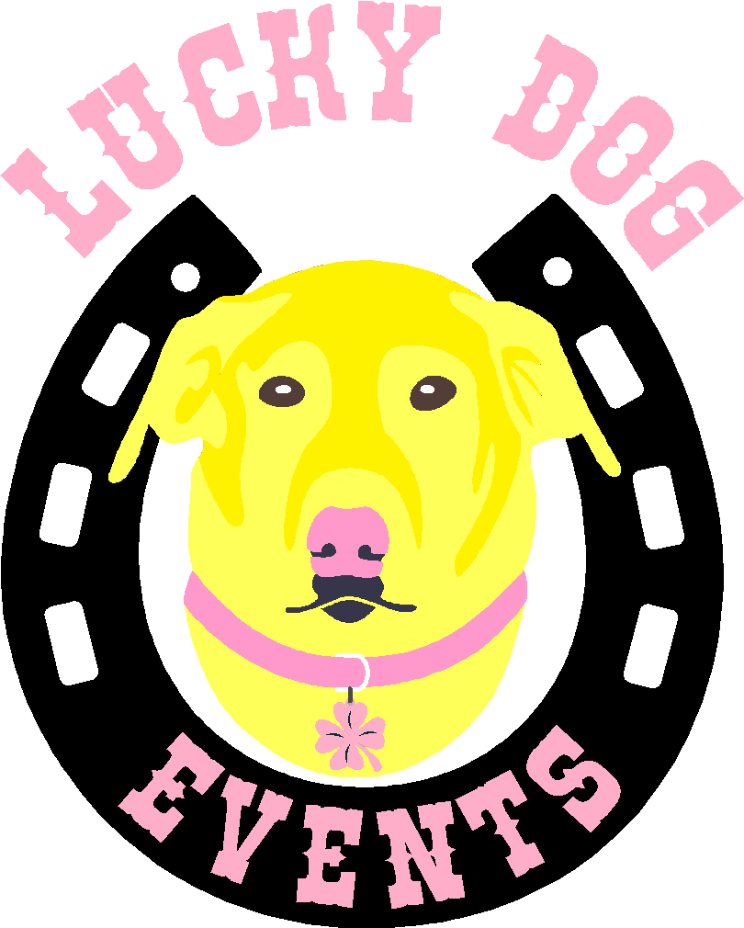 | 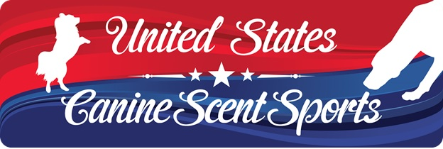

Trial Host: Lucky Dog Events
Novice Level /Classic & Game: Nov 5, 2017
Location: Hale Reservation 80 Carby St Westwood Mass
www.halereservation.org
Chief Search Designer:
Liz Lynch
Judge(s):
Rosemary Decie
Sally Underwood
Entry Cost:
$18 a class
Note: To be eligible for your Detection Dog Classic Novice title, you must enter all four element Classes. However, you may enter in as many Classes and Games as you wish.
DOS –entry fees $22 a class,

Classes offered on Nov 5
- (1) – Container - Novice and Intermediate
- (1) – Interior - Novice and Intermediate
- (1) – Vehicle- Novice and Intermediate
- (1) – Exterior= Novice and Intermediate
- (1)- ludicrous speed

Refund Policy/Event Cancellation
No refunds allowed after the pre-entry closing date except in the case of injured dogs (Veterinary note required). Refund will be 50% and those seeking a refund must request by 8:30 am on the day of the trial. Vet note must be received by Monday after trial and can be sent to Kim at luckydogevents@gmail.com.
Entry fees will not be refunded in the event that a dog is absent, disqualified, excused or barred from competition by action of the Event Committee. Every attempt will be made to hold this event as scheduled. In the event of an “act of God’ such as flood or fire, or civil disturbances or any other causes beyond the control of the organizing committee, the event may be canceled. We will make every attempt to contact entrants and inform them of the cancellation.

Number of Entries:
150 runs per Judge per day | Multiple dogs allowed, 2nd dog must run FEO. Titling dog must be run first | For Exhibition Only entries taken | Day of Show entries allowed if there is room. We will be nesting Novice and Intermediate so only 1 dog allowed for titling- if you want to run intermediate you cannot run FEO in Novice

Registration Entry and Closing:
Entries will be awarded on a first come, first serve basis, of all entries received between
the opening date and the closing date, which is Oct 27. Trial is open now

Note: For this location, handler and dog must be able to climb one flight of stairs. Some search areas may be upstairs,

Dogs must have valid USCSS™ registration numbers to compete in this trial. You can and should (whenever possible) register online and follow the payment instructions noted on the confirmation, we are only accepting checks at this time. If you want to enter offline, please fill out entry form below and mail with payment and waiver to Lucky Dog Events 26 Downey Street Hopkinton Mass 01748.

Steps for Joining USCSS™, Registering Dog and Entering this Trial:

- All competitors must become a member of USCSS™, which is free. Competitors may join here: http://members.uscaninescentsports.com/signup.
- Competitors must then register their dog(s) through the USCSS™ website. Each registration includes a one-time $25.00 fee. Competitors may register their dogs here: http://members.uscaninescentsports.com/login?redirectTo=http://members.uscaninescentsports.com/dog/register
- When logged into their account on the USCSS™ website, competitors may then scroll down to the “LOCAL EVENTS” section, find the trial they are interested in entering and click on the ENTER button.
- Competitors may then select which dog they are entering and select which Classes and/or Games they are entering.
- Competitors will then receive a confirmation email with details regarding their entry and instructions on how to submit payment for their entry. All payments will be sent directly to the trial host, not USCSS™. The confirmation email will specify how payment will be made (e.g. via PayPal, mailed check, etc.). Competitors should note that their spot in the trial will only be held once payment is made.

Schedule:

8:30am: Dog in White
8:30am: Check in for volunteers
8:30am: Cut off for Day of Show Entries (if space available)
9:00am Volunteer Dogs Run
9:30am Check in for Novice Dogs
9:45am Briefing
10:00am 1st dog on line

You are responsible for anything that is said at the briefing regardless of whether you attend it.

You also are responsible for ensuring your entries are correct. Any changes should be mail to the secretary before the closing date. Any changes requested day of will be charged a $5 fee.

AWARDS
- High in Trial rosette and USCSS™ T-Shirt
- High Rescue in Trial rosette
- High Champion of record rosette
- Dogs must be entered in a minimum of 4 classes at each trial to be eligible for any HIT awards
- 1st - 4th place overall
- Above will only be awarded it there are 150 or more runs for the day.
- 1st - 4th place per class
All ribbons must be picked up day of trial. No ribbons will be mailed out.

LUNCH
We will have lunch at approximately noon and will take breaks at the Judge’s discretion.
We will have a pot luck lunch – please bring something to share.

VOLUNTEERS
Every Trial relies on great volunteers to run smoothly and efficiently. Please sign up to volunteer at this trial if you can. Volunteers will earn LDE CASH to use at future Lucky Dog Events. Snacks and drinks will be provided to workers. Please e-mail Luckydogevents@gmail.com if you are willing to volunteer. THANK YOU in advance for volunteering!

Workers needed
1 parking attendant
2 Timers/Judges assistant
2 Gate Stewards
2 Sheet Runner

VETERINARIAN

Angell Animal Medical Center
350 S. Huntington Ave.
Boston MA 02130
Phone: 617-522-7282
Email: emergency@angell.org

Exhibitor Information:
The following dogs are eligible to compete in USCSS™ events:
• Dogs 6-months of age or older
• Dogs of any breed, purebred or mixed breed
• Blind, deaf or dogs with amputations or who use ambulatory carts
• Bitches in season but they must wear panties and be kept separate from all other dogs and will be run at the end of their class/trial. If bringing a bitch in season, please inform the trial secretary prior to the trial and inform all exhibitors at the judge’s briefing.
• Reactive dogs, and USCSS™ suggests they wear red bandannas

Leash and Collars:
All dogs must be on a short leash and under control while on trial grounds except while showing. Flexi/retractable leads are not permitted on USCSS™ sanctioned trial grounds. No choke chains, prong collars or halti/head collars are permitted at Lucky Dog Events. Leashes of any length may be used while the dog is participating in a run during a Class, but they must be switched over to a 6’ length leash when outside of the search area.

There is NO SMOKING in this facility or on the grounds. The trial will be held indoors, and outdoors. Surfaces used for searches will be rubber matting, wood floors, rugs, dirt, and grass.

Crating
There will be no crating space available inside the building
IMPORTANT: Only soft or metal crates are allowed - no x-pens. If the weather is nice, you can crate out of your car or outside. All crates MUST have a tarp/blanket/towel/mat underneath them, between the crate and the matted flooring. Please be careful about water spillage on the mats.

PLEASE CLEAN UP AFTER YOUR DOG!
Dispose of waste in appropriate containers outside the building. Do NOT let your dog pee on items we have to touch! This is a rental, and we want to be able to come back. .

Please bring adequate shade and water for you and your dogs.

Trial Chairperson
Kim Lewis
luckydogevents@gmail.com

Trial Secretary
Julieanne Bovat

For information about the trial, please email Kim.

For information about the organization, please email United States Canine Scent Sports at info@USCanineScentSports.com

PLEASE FILL OUT WAIVER BELOW. THIS IS REQUIRED TO COMPETE. IF YOU PAY ONLINE, PLEASE BRING WITH YOU DAY OF SHOW. IF YOU MAIL PAYMENT, PLEASE SEND IN WITH YOUR PAYMENT

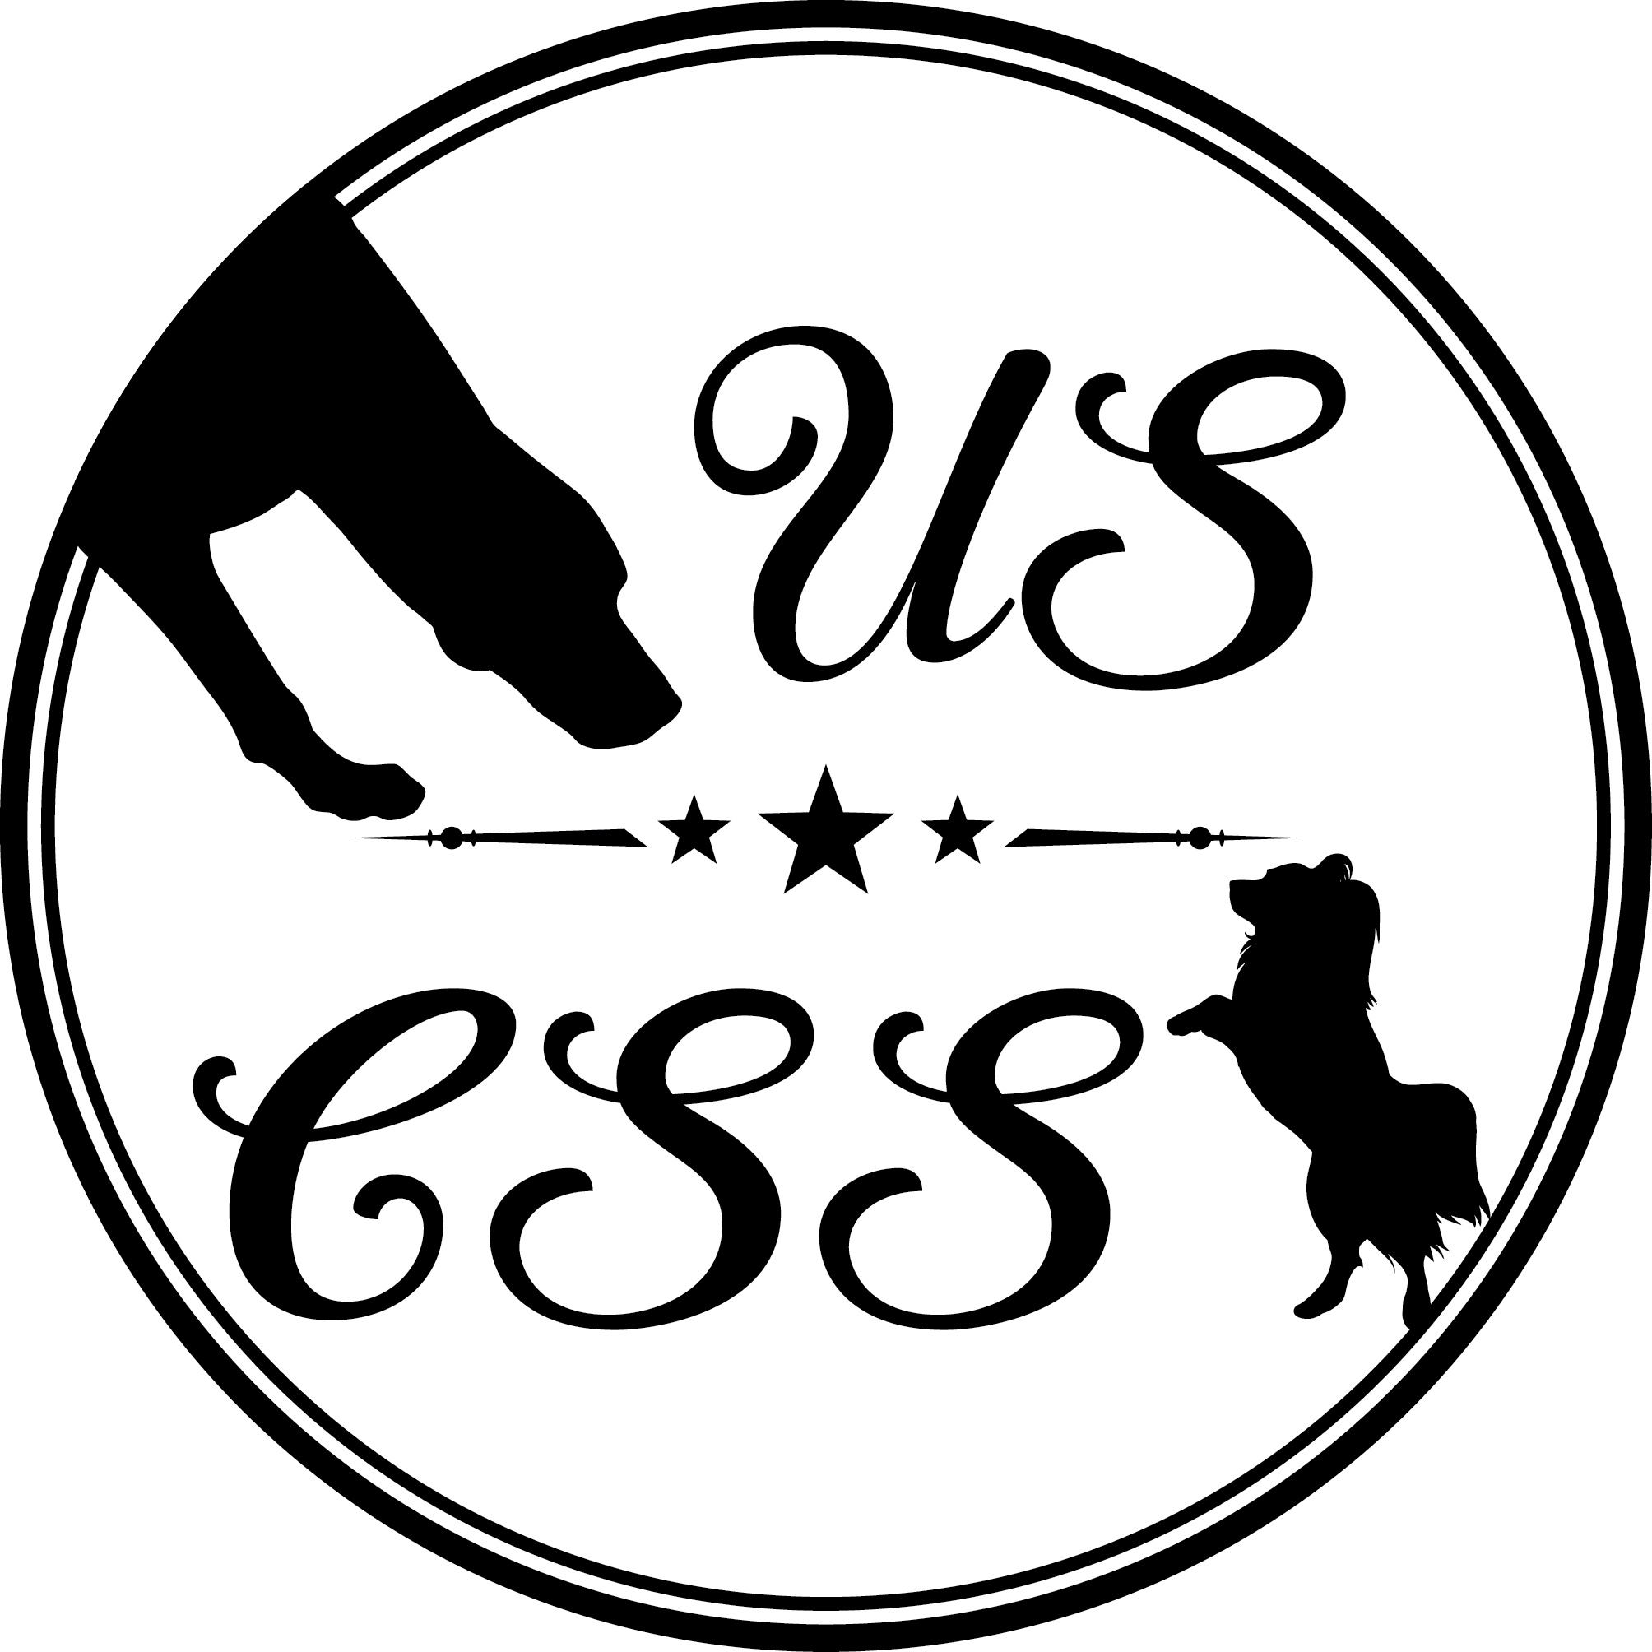 |  | 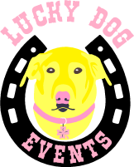
Nov 5, 2017 Trial |  | USCSS™ Entry Sheet
COMPETITOR INFORMATION
Competitor’s Name: ___________________________________________________________
Dog’s Name: ________________________________ Dog’s USCSS™ No.:______________ Dog’s Breed: __________________________ Rescue? Y N Ch. Of Record? Y N
CLASS PRICES
CLASSES OFFERED
Class Type | Level |  | T , FLO, or FEO |  | Entry Fee
Interiors
Exteriors
Vehicles
Containers Ludicrous Speed
 |  |  |  | TOTAL ENTRY FEES:

Please send with payment and waiver to:
Lucky Dog Events, 26 Downey Street Hopkinton, MA 01748

USCSS™ & Luck Dog Events Waiver and Release Agreement

I hereby certify that I will hold harmless any and all persons connected in any capacity whatsoever in regards to the training classes, Pay and Plays, Show and Go’s, Clinics, Private Lessons, USCSS™ Events, Trials and Shows from any and all liability, costs and expenses for any injury or damage sustained by or to myself, or by or to my dog(s). I also certify that there will be no legal liabilities held against United States Canine Scent Sports™, Action Dog Sports, Daneen Fox, Julie Sandoval, any USCSS™ Director, Officer, Agent or Employee, Lucky Dog Events, or any owner of places we rent from, or any USCSS™ Affiliate, Director, Officer, Agent, Employee or Volunteer for any damage sustained by me or my dog(s), or any family member or other person accompanying me, in connection with this training class or event. I further agree and release USCSS™ to be permitted to use photographs and video footage taken during USCSS™ Trials, Shows and Events for promotional purposes, which may include the USCSS™ website, marketing materials or official USCSS™ presentations.
Name: | ___________________________________
Street Address: | ___________________________________
City, State, Zip: | ___________________________________
Email Address: | ___________________________________
Dog(s) Name(s): | ___________________________________
___________________________________ | __________
Signature | Date

